Zion Reformed United Church of Christ

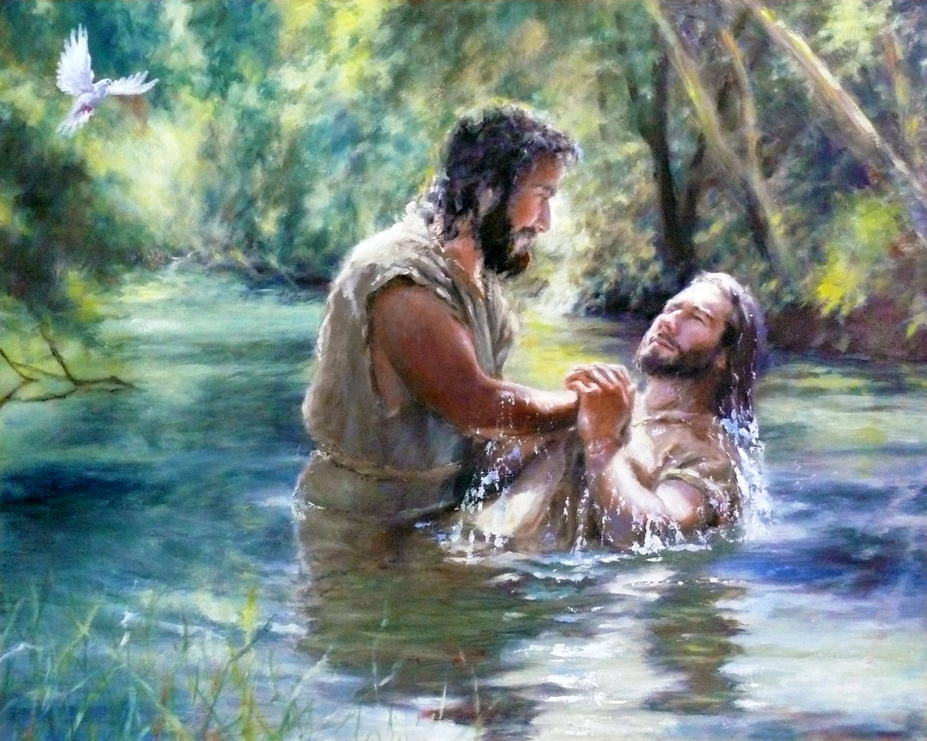

epiphany Sunday

January 15, 2023 11:00am

A light shines!

Our Mission Statement

To share the gospel of Christ in such a way that we find God, grow our faith, discover our purpose and make a difference

Second Sunday after Epiphany
January 15, 2023 ❧ 11:00 A.M.
Meditation of the Day “Love is the only force capable of transforming an enemy into a friend.” ~Martin Luther King, Jr.
WE GATHER TO PRAISE GOD
* All who are able may stand

Gathering Music: “Salzburg Melody”

Ringing of the Bells
Prelude “What Star Is This” arr. By Robert Lau
Words of Welcome
*Call to Community ~based on John 1 & Genesis 1
In the beginning was the Word
In the beginning, we were created in God’s image
And the Word was with God and the Word was God
Male and female God created us, and God blessed us
All things came into being through Christ and without Christ not one thing has come into being.
God saw everything God made, and it was very good.
What has come into being in Christ was life, and the life was the light of all people,
We are created in God’s image. We are created to be good. We are created to be loved.
We are God’s light in this world. Let us worship Christ and be the light.
*Opening Hymn “Brightest and Best” Black 157
Children’s Time

WE HEAR GOD’S WORD

First Reading Isaiah 42:1-9 Amber Nilson

Here is my servant, whom I uphold, my chosen, in whom my soul delights; I have put my spirit upon him; he will bring forth justice to the nations. He will not cry out or lift up his voice or make it heard in the street; a bruised reed he will not break, and a dimly burning wick he will not quench; he will faithfully bring forth justice. He will not grow faint or be crushed until he has established justice in the earth, and the coastlands wait for his teaching. Thus says God, the Lord, who created the heavens and stretched them out, who spread out the earth and what comes from it, who gives breath to the people upon it and spirit to those who walk in it: I am the Lord; I have called you in righteousness; I have taken you by the hand and kept you; I have given you as a covenant to the people, a light to the nations, to open the eyes that are blind, to bring out the prisoners from the dungeon, from the prison those who sit in darkness. I am the Lord; that is my name; my glory I give to no other, nor my praise to idols. See, the former things have come to pass, and new things I now declare; before they spring forth, I tell you of them.

Choral response On Eagles Wings Black 775

And God will raise you up on eagles' wings
Bear you on the breath of dawn
Make you to shine like the sun
And hold you in the palm of Gods hand

Second Reading Matthew 3:3:13-17 Rev. Katie Penick
Then Jesus came from Galilee to John at the Jordan, to be baptized by him. John would have prevented him, saying, “I need to be baptized by you, and do you come to me?” But Jesus answered him, “Let it be so now, for it is proper for us in this way to fulfill all righteousness.” Then he consented. And when Jesus had been baptized, just as he came up from the water, suddenly the heavens were opened to him and he saw God’s Spirit descending like a dove and alighting on him. And a voice from the heavens said, “This is my Son, the Beloved, with whom I am well pleased.”

The Message Ever-flowing Waters of Grace
Invitation to Give
Offertory “There is No Night”
Choral Response Let There Be Peace On Earth

Let there be peace on earth
And let it begin with me
Let There Be Peace on Earth
The peace that was meant to be
With God as our Father
Family all are we
Let us walk with each other
In perfect harmony.
Let peace begin with me
Let this be the moment now.
With ev'ry step I take
Let this be my solemn vow
To take each moment and live
Each moment in peace eternally
Let there be peace on earth
And let it begin with me

Blessing Our Gifts
Giver and Sustainer of Life, pour out your blessing upon these gifts and upon all who give from their hearts. Multiply them so they reach farther than our imaginations can carry them. In the blessed name of our Redeemer, we pray. Amen.

Remembering Our Baptism and Sacrament of Communion
*Hymn of Preparation “Come Thou Fount of Every Blessing” Red 476
Invitation
Today is a sacred and special day, as we celebrate our two sacraments together. This morning we remember the sacrament of our baptism as we share in the sacrament of communion. One celebrates birth and new life, and the other, our continued nourishment and growth as we live into all Christ calls us to be.
We remember our baptism and are thankful for the gift of new life!
We come to the table, where God continues calling us each by name to bring us into the fullness of the new life.
We come to this place, listening for the guidance of the Spirit!
Passing the Peace
Now let us share signs of that peace which we find in Christ with our neighbors!
The Great Thanksgiving
God be with you.
And also with you.
Lift up your hearts.
We lift them up to God.
Let us give thanks to the God we love
We freely give God thanks and praise.
It is right and meet, beautiful and holy
that we should, in ceaseless joy
Give our thanks and praise to you,
Holy and merciful God,
Through Jesus Christ, our Savior.
And so, in grateful procession of endless praise
With the church that is, was, and shall be forever.
The Story
And so we recall that on the night of betrayal and desertion,
The light of the world took bread, broke and gave it to the disciples, saying:
“This is my body, given for you.
Do this for the remembrance of me.”
And, in the same way, after supper,
Jesus took the cup and after giving thanks give it to them saying,

“This is the cup of the new covenant
poured out for you and for all people
for the forgiveness of sins.
Do this, as often as you drink of it,
for the remembrance of me.”
Life’s greatest feast before us,
We excitedly proclaim:
Christ has died Christ is risen Christ will come again.
Dear God, you transform.
You transform all that is before you
So that at the touch of your grace
We are never the same.
Dear God, you illumine.
You bring light to all peoples
Light to the nations
Light into our hearts
Light on your Way.
Dear God, we pray for your Spirit.
Transform, illumine, bless.
Make these ordinary gifts of bread and cup
Into the extraordinary presence of Christ with us.
In so doing,
Hold us as your own
Renew us as your people
For the sake of the world you love.
For all honor and glory are yours, O God,
Through Jesus Christ,
Who lives and reigns with you and the Holy Spirit in your glorious creation
Both now and forever.
Amen.
Sharing the Meal and Remembering our Baptism
You are invited to come forward. After you receive your bread and cup,
proceed to the baptismal font. Please dip your hand in the waters,
turn to the person behind you, touch their forehead and say:

“You are God’s Beloved!”

Communion Prayer
Let us pray:
We have been fed, Holy One, by your presence.
We have been led, Eternal One, by your light.
May we bask in this glow
Now and forevermore.
Prayer of Our Savior
Our Father, who art in heaven,
Hallowed be thy name.
Thy kingdom come.
Thy will be done on earth as it is in heaven.
Give us this day our daily bread.
And forgive us our debts, as we forgive our debtors.
And lead us not into temptation, but deliver us from evil:
For thine is the kingdom, and the power, and the glory,

Forever and ever. Amen.

*Closing Hymn “Jesus the Light of the World” Black 160

(Barbara will play this once before the verses to familiarize everyone with it.)

*Sending Forth

Postlude “Carol of the Bells” Mykola Leontovych

GO FORTH IN PEACE & SERVE!

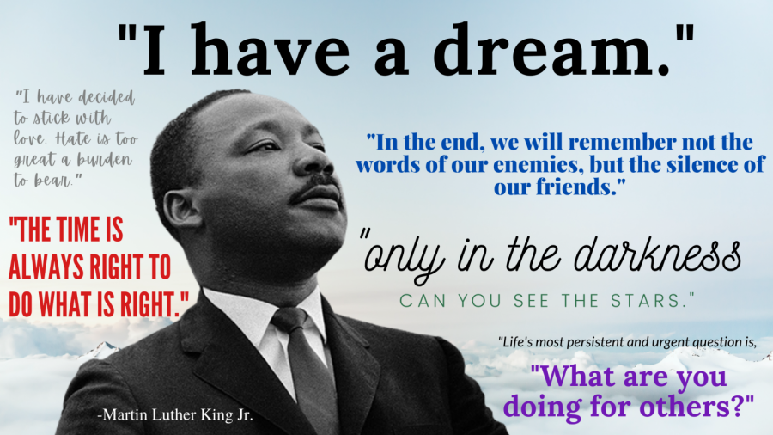

Upcoming events

Jan 16 - The Church Office will be closed in observance of the Martin Luther King, Jr. Birthday Holiday.
Jan 17 - ONA team meeting 12:30 in the Burhans Room
Jan 19 – Lunch Bunch book Club 11:30 in the Burhans Room
4-H Club Meeting 4:30
Jan 22 – Guest Preacher for Sunday Service – Sheresa Simpson-Rice, Associate Conference Minister for
Leadership Development
Youth Group Planning Meeting after worship for all youth and their families. Lunch will be provided.

Mark your calendar for Saturday February 25th – REACH of Washington County Coldest Night of the Year fundraiser to draw attention to the plight of the homeless during the cold winter months. Additional information is on the CNOY website at https://cnoy.org/about. If you are interested in participating, please contact Carroll Sager at carroll.sager@gmail.com.

Praying with One Another
Prayer is one of the most important spiritual disciplines of our faith, promoting communication with God, and love for God and neighbor. Submit your prayer requests to the church office to be included on the prayer list. Join with us in prayer as we pray for all those in our communities that we have touched or that have touched us and those that simply crossed our paths. Let us also remember to pray for peace and safety around the world and to pray with and for our Zion siblings: Holly Bell, Naomi Brackett, Brenda, Gladys Burk, Linda Cantilena, Richard Cantilena, Kim & Bill Cook, Ronald Curry Sr., Shirley Flanagan (Sue Greaff’s Aunt), Shawnee Forciho, Joanna and Derrick Garber, Carol Garland, Michael Graff Jr. (son of Sue and Mike), Beth Gross, Hart Family, Hess Family, Sherry Hockman, Lyn Hoffmaster, Jane Hollabaugh, Paul Hose, Ann Kalinoski, Rhondda Kane, Alyssa Kline, Dee Krause, Livingston Family, Sofia Martinez, Dee McGlauckin, Barry & Amy Newlin, Annie Penick, James Penick, Mark Plotner, Price Family, Colleen Rand, David Ridenour, Betsy Roulette, Verna Rosenfield, Claudia Ruth, Jeff Shade, Lori Schmidt and Family, Ralph & Scherry Sellers, Staci Shafer, Angel Shorts & Family, Thelma Summers, Tracy Roach Walls, Eleanor Wible, Eric Wolbring, Robert Yeoman, Yvette, and the Ziegler Family.
*Prayer Requests remain active on the prayer list for 4-weeks unless renewed.

Adapted from https://www.ucc.org/worship-way/communion-service-for-epiphany-season/

Gathering Music: Le Sommeil de l’Enfant Jesus Traditional French: harmonized by Francois Gervaert 1828-1908 performed by B. Hendershot of Zion Reformed UCC
Still, Still, Still Traditional Austrian Salzburg Melody, 1819 performed by B. Hendershot of Zion Reformed UCC
Lully, Lullay (Coventry Carol) Thomas Mawdyke in the Pageant of Shearman and Tailors 1591, arr. By C. Gill performed by B. Hendershot Zion Reformed UCC
In the Bleak Midwinter Christina G. Rossetti 1872 alt. New Century Hymnal song #128 Tune: Cranham Irr, Gustav Holst, 1906 performed by B. Hendershot Zion Reformed UCC
I Wonder As I Wander Traditional Appalachian Tune composed by John Jacob Niles performed by B. Hendershot Zion Reformed UCC

Prelude: What Star Is This Tune Puer obis: arr. By Robert Lau, Lorenz Publishing ©2016 performed by B. Hendershot Zion Reformed UCC

Hymns: First Hymn - -Brightest and Best New Century Hymnal song #157 composed by Reginald Heber 1811 tune: Morning Star by James P Harding 1892 The New Psalms and Hymns, Richmond, VA 1901 performed by B. Hendershot Zion Reformed UCC
Hymn of Preparation – Come Thou Fount of Every Blessing The Hymnal song #476 composed by Robert Robinson 1758 John Wyeth 1812 performed by B. Hendershot Zion Reformed UCC
Closing Hymn - Jesus the Light of the World New Century Hymnal song #160 composed by Charles Wesley 1739 adap. George D. Elderkin arr.by Jeffrey Radford 1993 performed by B. Hendershot Zion Reformed UCC

Offertory: There Is No Night www.ChamberHymns.com transcribed by Ben Chan performed by B. Hendershot Zion Reformed UCC

Communion Music: At This Table Idina Menzel and Jonas Myrin ©2019 Idina Music, EMI Blackwood Music, Inc. Duva Island and Songs of Universal Sony/ATV Music and Universal Publishing performed by B. Hendershot Zion Reformed UCC

Postlude: Postlude on a Ukranian Carol Tune: Carol of the Bells by Mykla Leontovych arr. By Alfred V Fedak ©2017

